Add a new role called **efiling_early_access** to the **e-divorce-app** client in Keycloak

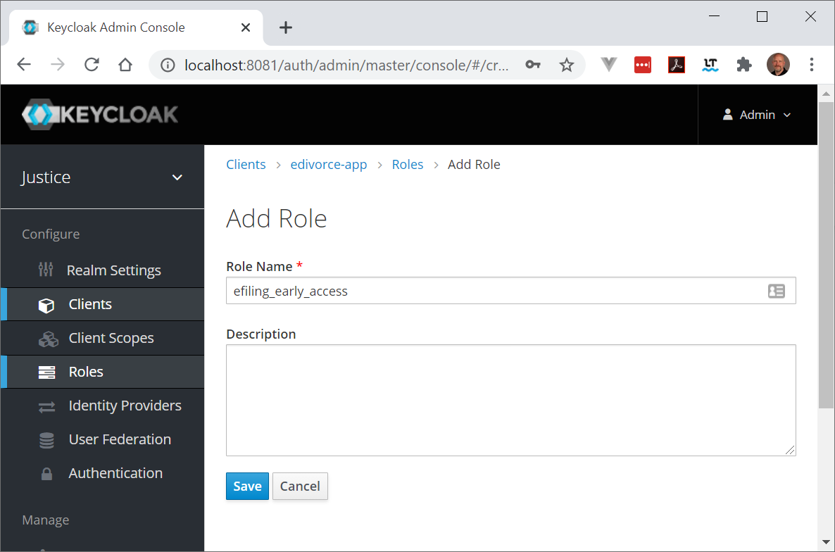

Add the built-in mapper for “client roles” to the e-divorce-app client

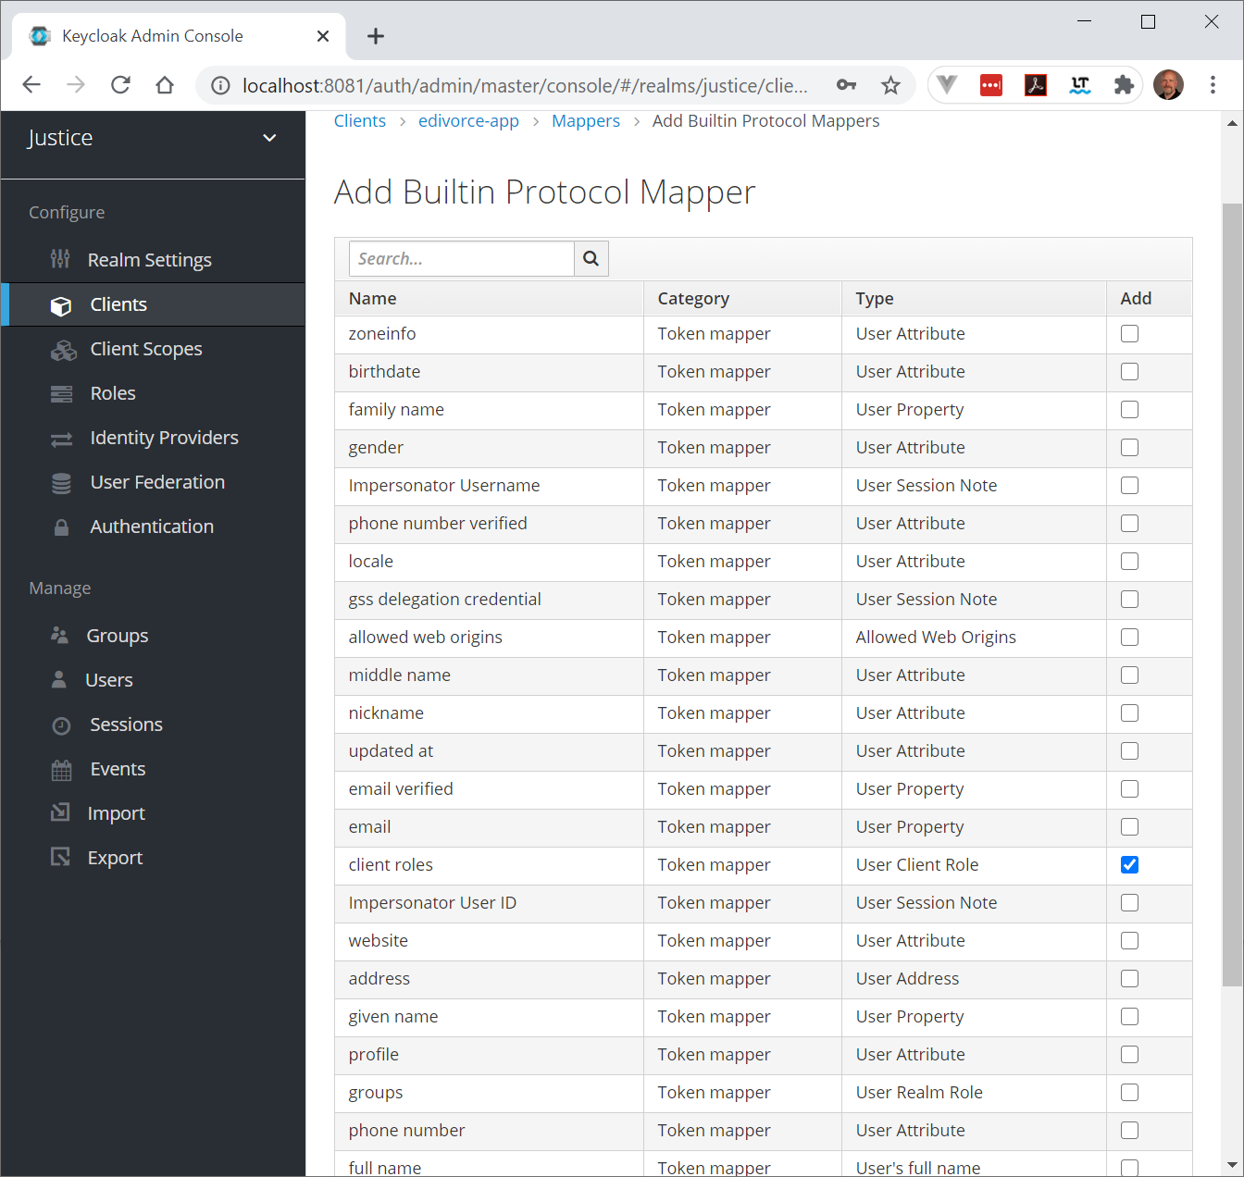

Set the Client ID to “e-divorce-app”. Edit the client mapper and set Token Claim Name to “roles” and select “Add to userinfo”

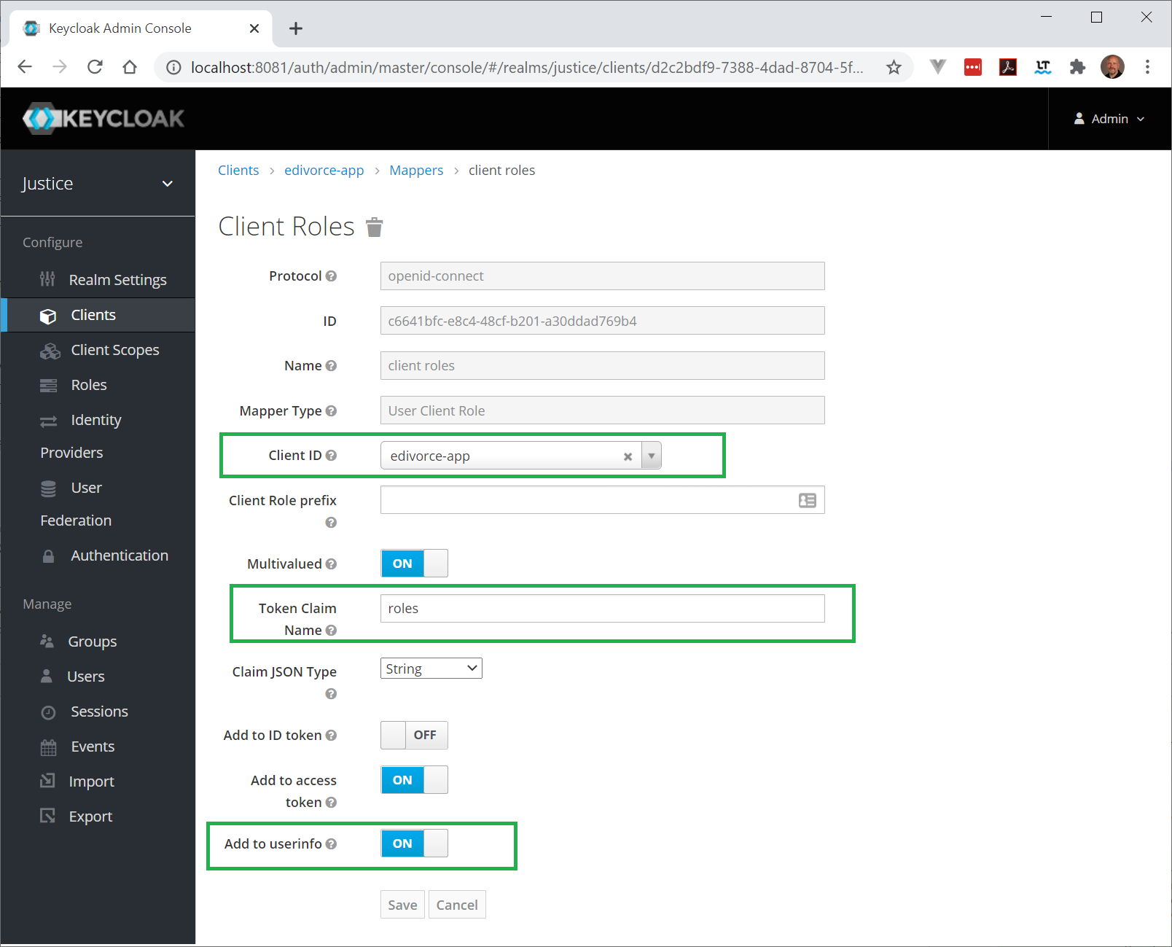

Note: Renaming the Token Claim is necessary because of a bug in Keycloak. This bug is fixed in Keycloak 11.

<https://keycloak.discourse.group/t/resource-access-claim-missing-from-userinfo-until-i-change-the-name/1238>

Assign users to the new Client Role as needed

